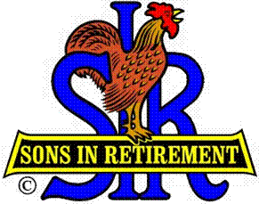
Las Trampas Branch 116
Luncheon Meeting Agenda
August 19, 2019, 11:30 AM
Hawaiian Shirt Day
09:30 BEC Meeting
10:30 Social Hour
Greeters – Terry Grummitt and Chris Doan
Raffle – Ben Bryce and Mike Yale
New Member Orientation – Max Foust
11:25 Five Minute Call
11:30 Call to order; Opening Remarks – Big SIR
Pledge of Allegiance – Ernie Wong, US Army
Chaplain – Doug Aalders
Sunshine Report – Matt Arena
11:37 Story Teller – Pete Coggiola
11:41 Introduce Speaker – Bob Fish
Guests – Recruitment - Don Schroeder or Host
Dr. Bob Wells (Don Benioff)
Paul Russell (Gary Boswell)
New Member Introduction – Jerry
Darrel Dummet (Fred Schafer)
Jamie Watson (Art Donaldson)
Leo Vardas (Dick Savage)
Recognize Greeters – Jerry (Terry Grummitt and Chris Doan)
Awards – Phil Jenkins – 20 year certificate
11:45 Salad Served
11:46 Election of 2020 Officers and Directors – Marty Katz
Please come forward as you name is called for picture
11:55 RAMP Department Heads Reports (If time)
12:00 Lunch
12:35 Activity Committee Reports
12:45 Speaker – Bob Fish: USS Hornet’s Role in the Astronaut Program
13:20 Speaker Thank You
13:22 Raffle Drawing – Ben Bryce, Mike Yale
Birthday Drawing – Jerry
13:25 Closing Remarks – Big SIR
13:25 Sing Happy Birthday - Music
Sing God Bless America
13:30 Adjourn; Next Meeting, September 16, 2019 (Kathy’s Birthday)

